Ahmann LLC
Architectural Services
4408 Beechwood Rd
University Park, MD, 20782

RE: Invoice 16024

Tom: | March 16, 2016

I received your invoice and was surprised. I am including payment of $412.50 for services that I requested and for services rendered without a request. Here’s how I came up with $412.50.

Invoice shows $237.50 for review of window and door submittal. I requested this and I will pay this, though I am surprised it took 2 hours.

Invoice shows $262.50 for site meeting. I do not think this charge is appropriate. I didn’t ask for this. I never received any report from you about this meeting, written or verbal. From the contractor, you insisted that he follow the plans, which led to a cascade of extra effort and cost. In my opinion, the best plan would have been to make the frame and the addition fit the wall; that wouldn’t have led to any additional effort or cost.

Invoice shows $350 for party wall change order review (I don’t think your dates are right on the invoice: it was Feb 25). I will pay half of this $175 to pay for the phone call consultation and as a token of my appreciation that you had my best interests in mind at that point in time. I am not paying the full price because I don’t believe I asked for this review. I remember asking your opinion on the phone whether or not the change order was warranted. I remember saying that I might need some bullet points from you to make my arguments to the contractor and that I would get back to you with more information. I remember you saying you could do that. By the end of the day, I did not contact you because I didn’t need those bullet points. That night I saw your email with your review. It was well done and appreciated, but I knew it wasn’t going to change anything.

$237.50 + $175 = $412.50

I regret that this last interaction is not falling to your expectations. To avoid this problem I want us to be clear on any costs for any work to come, if any. I am happy to pay your going rate for phone consultations (15 minute increments); I know we are on the clock. If we discuss work on the phone, we should exchange emails outlining the scope of work and agreeing to the terms; no surprises.

Sincerely,
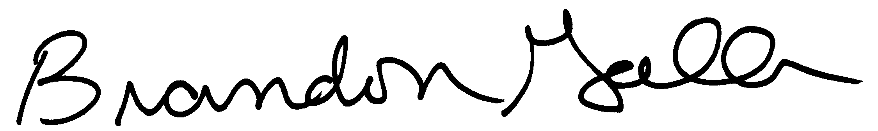

Brandon Gallas

